Communication and Language  Retelling rhymes filling in the missing words.  Using pictures to sequence rhymes, for example making books retelling Humpty Dumpty.  Creating a sound scape for Humpty Dumpty, selecting instruments to represent different sounds/actions  Finding pairs of objects that rhyme  Make up class versions of traditional rhymes.  Daily ‘Letters and sounds’ activities to support early phonological awareness, playing games such as ‘Mrs Bear Lives in a cave’ listening to the syllables heard in their names and other key vocabulary | Understanding the World  Observing different types of weather.  Planting bulbs in the garden, finding out about the conditions required for growth.  Observing the changes that occur with the season, looking for signs of autumn.  Using microphones to record nursery rhymes/making a nursery talking book of favourite rhymes | Personal, Social and Emotional Development  Small group activities to support turn taking and sharing.  Ongoing discussion about the routines within the setting and how to behave.  Planned settling in curriculum to support transition in to Hawley. |  | Literacy  Reading a range of stories that support the rhyme for example for Cobbler, Cobbler mend my shoe reading the Elves and the shoe maker.  Book making activities using photographs of the children dressed up and acting a story. Or drawing the beginning, middle and end of the story.  Dressing up to act out familiar stories to support vocabulary development.  Daily story time to support children becoming familiar with a range of stories.  Drawing activities based on the rhyme for example drawing a brick wall for Humpty Dumpty.
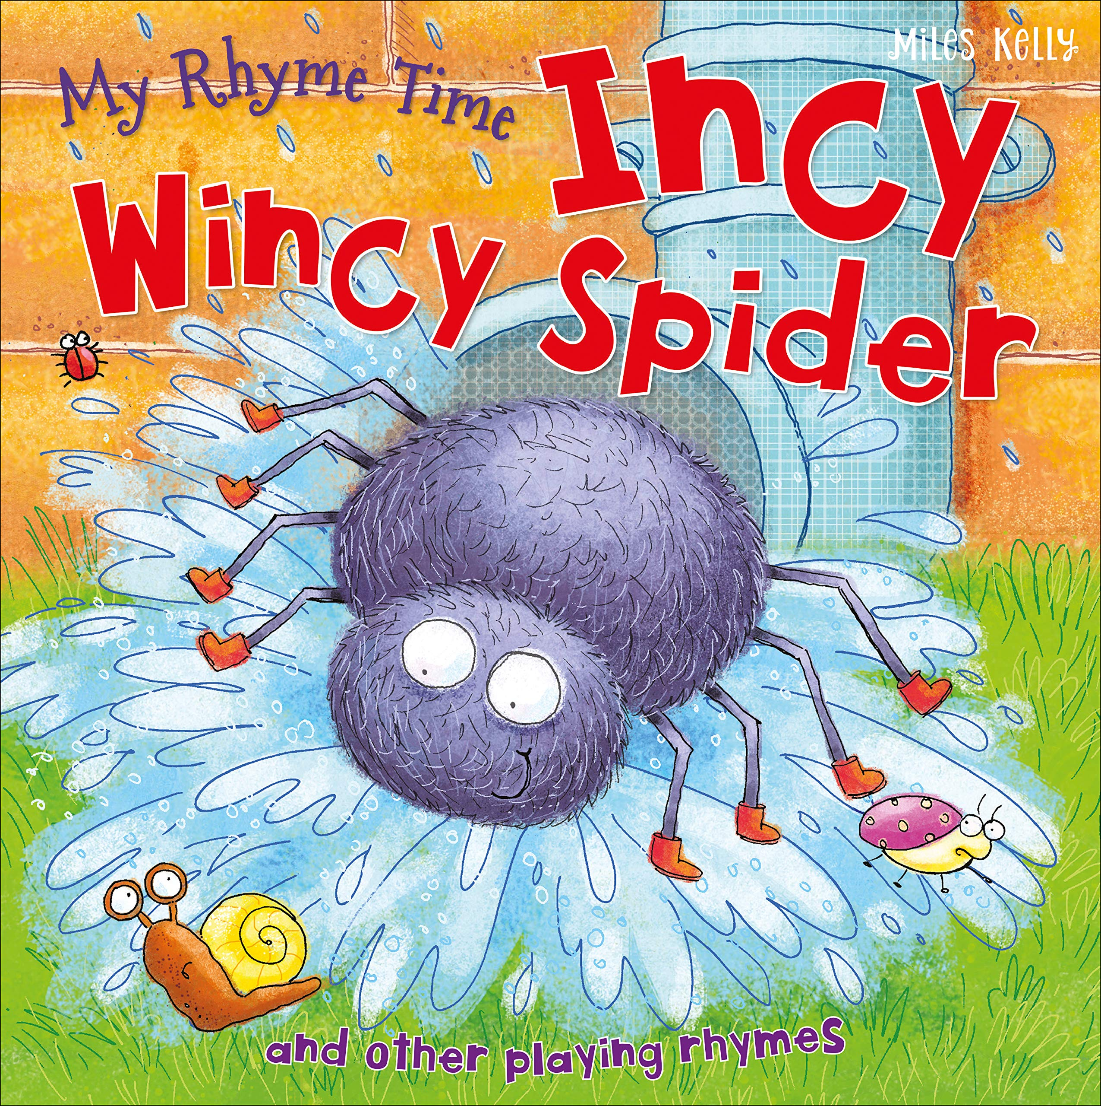
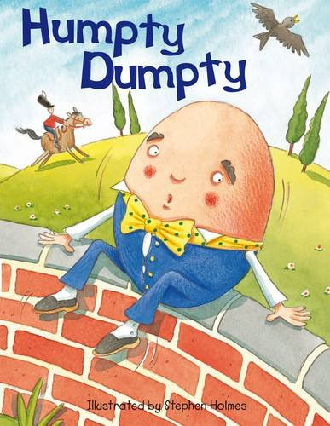
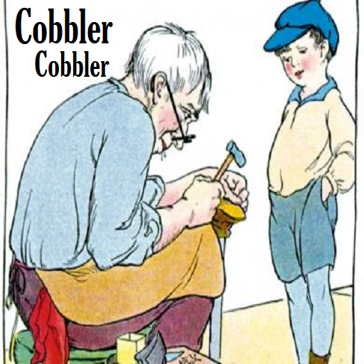
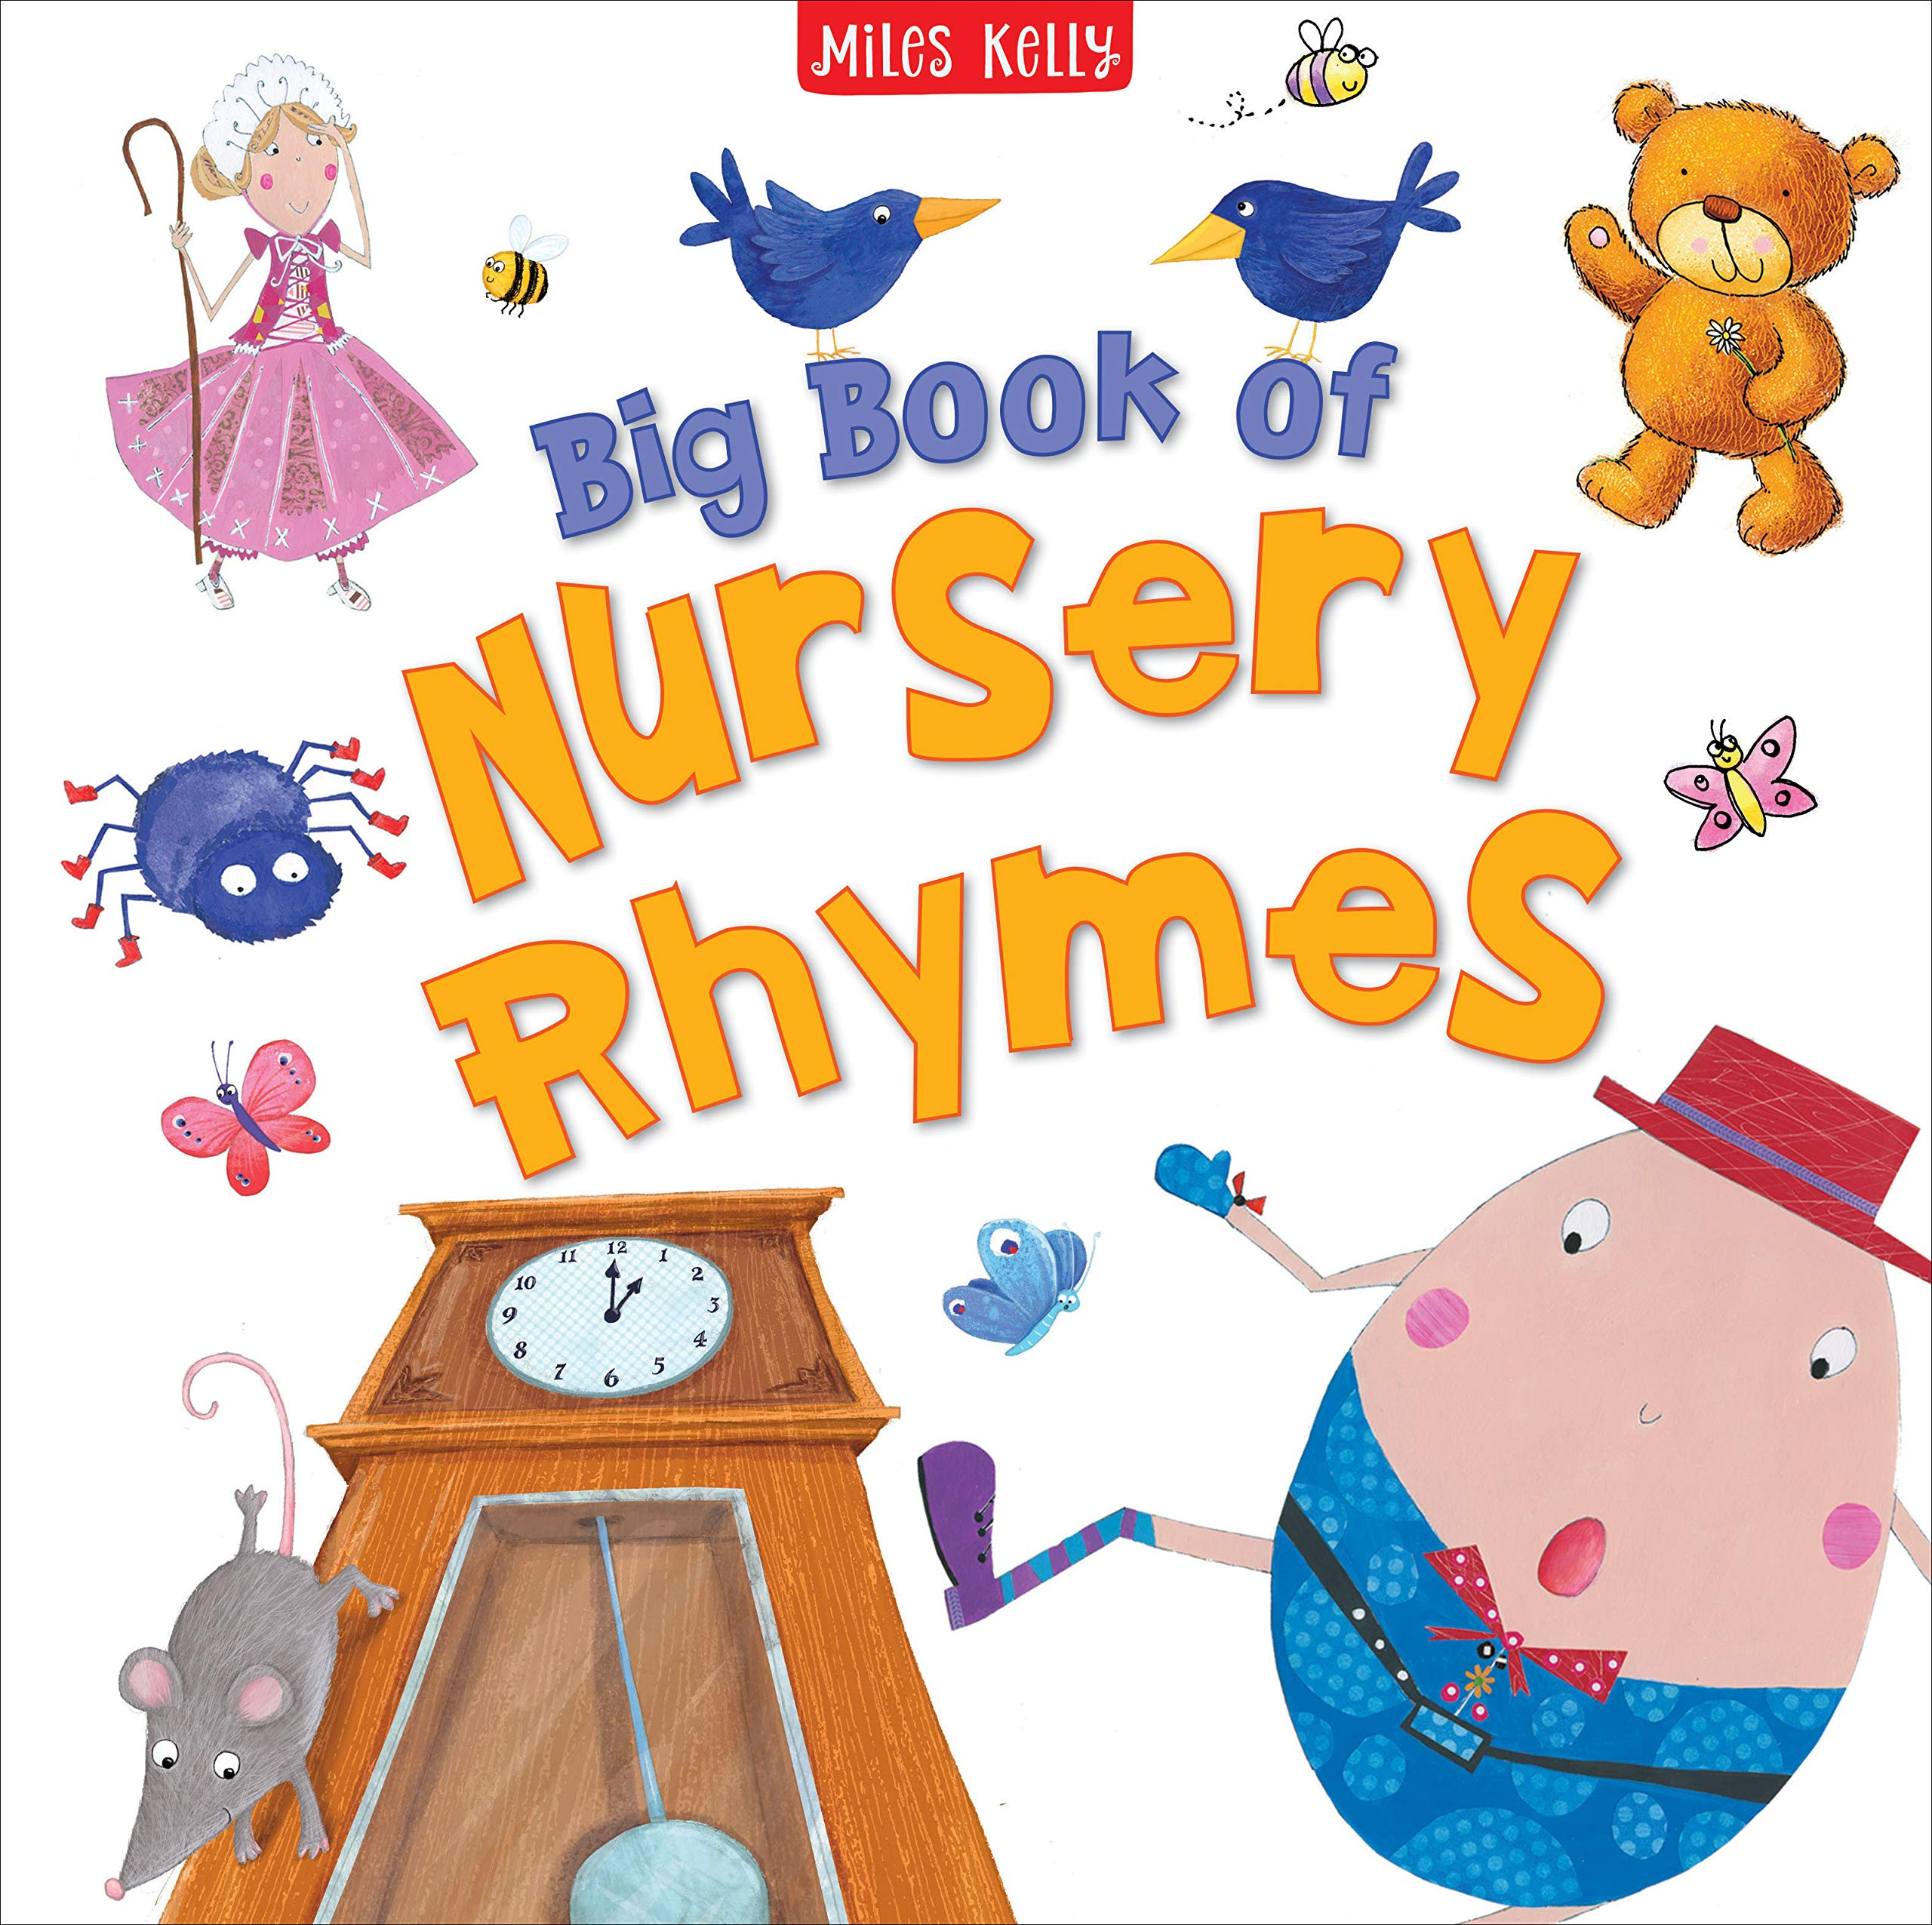

Nursery Rhymes

Physical Development  Ongoing opportunities to use a range of mark making tools inside and outside, for example drawing a web for the spider.  Using climbing equipment in the outside area.  Acting out chosen rhymes, curling up like Humpty Dumpty, climbing up and down like Incy Wincy spider.  Obstacle course based on Duckie’s Rainbow, walking under / around and through |  |  |  | Mathematics  Use shapes to create collages based on nursery rhymes, for example making a duck.  Look at brick patterns and print brick patterns using rectangles.  Daily counting activities based on rhyme for example counting ducks on to the pond or eggs into a nest.  Counting pegs onto numbered spiders  Become familiar with numbers 1-3 (and beyond) order on a number line  Using blocks to construct models  Begin to look at simple patterns
 | Expressive Arts and Design  Using construction materials to create a brick wall, looking at the difference between a tower and a wall.  Making spiders, selecting different materials.  Rolling balls in paint and adding collage materials to make a spider’s web  Builder’s role play, building a wall for Humpty dumpty  Builder’s role play. Elves workshop |  | Characteristics of Effective Early Learning  Humpty Dumpty challenges linked to rhyme, for example Humpty Dumpty is stuck in a tree how can we rescue him?  Design and make a shoe that is waterproof.  Making a moving Incy Wincy Spider picture, how can we move the spider up the drain pipe?

